Lab One

- How Long is a Year?

#include "library.h"

int yearfunction(int sec, int min, int hr, int d)
{
int answer = (sec * min * hr * d);
return (answer);
}

void main()
{
print(yearfunction(365, 24, 60, 60));
}

Result:
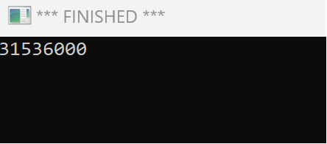

- Black Magic, Star

#include "library.h"

void main()
{
make_window(400, 400);
set_pen_color(color::red);
set_pen_width(5);
move_to(150, 250);
turn_right_by_degrees(18);
draw_distance(100);
turn_right_by_degrees(144);
draw_distance(100);
turn_right_by_degrees(144);
draw_distance(100);
turn_right_by_degrees(144);
draw_distance(100);
turn_right_by_degrees(144);
draw_distance(100);
//Title
move_to(150, 290);
set_pen_color(color::black);
set_font_size(40);
write_string("Star");
}

Result:
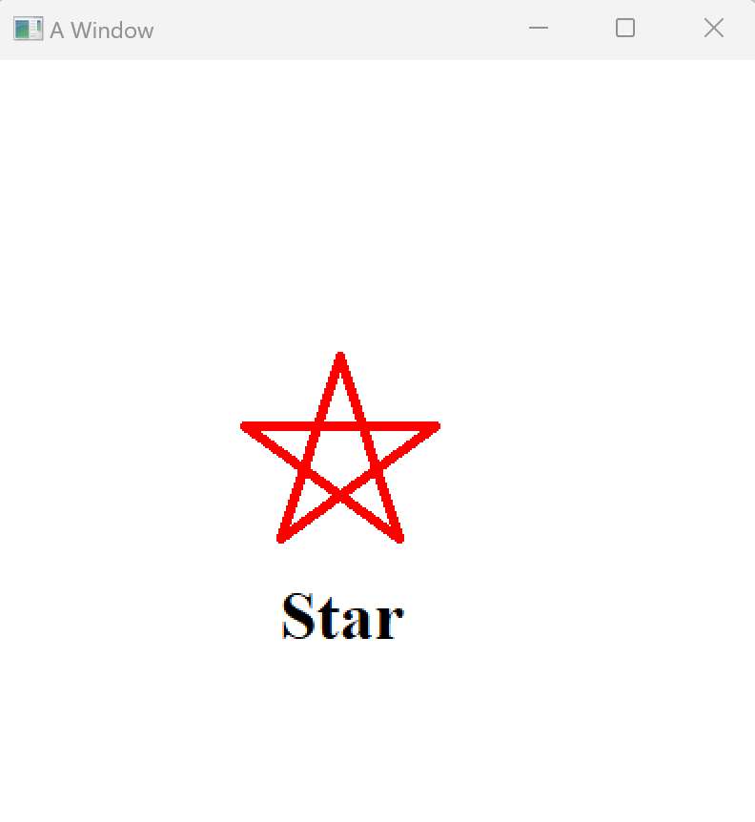

- Stick Men, Round Heads

#include "library.h"

void main()
{
//Head
make_window(400, 400);
set_pen_color(color::black);
set_pen_width(100);
move_to(200,90);
draw_distance(1);
set_pen_color(color::white);
set_pen_width(90);
draw_distance(1);
//Eyes
set_pen_color(color::black);
set_pen_width(10);
move_to(180, 80);
draw_distance(1);
set_pen_color(color::black);
set_pen_width(10);
move_to(220, 80);
draw_distance(1);
//Mouth
set_pen_color(color::black);
set_pen_width(5);
move_to(180, 110);
turn_right_by_degrees(90);
draw_distance(40);
//Neck/Torso
set_pen_color(color::black);
set_pen_width(7);
move_to(200, 140);
turn_right_by_degrees(90);
draw_distance(150);
//Legs
set_pen_color(color::black);
set_pen_width(7);
move_to(200, 290);
turn_right_by_degrees(30);
draw_distance(100);
set_pen_color(color::black);
set_pen_width(7);
move_to(200, 290);
turn_right_by_degrees(300);
draw_distance(100);
//Arms
set_pen_color(color::black);
set_pen_width(7);
move_to(200, 190);
turn_right_by_degrees(100);
draw_distance(100);
set_pen_color(color::black);
set_pen_width(7);
move_to(200, 190);
turn_right_by_degrees(160);
draw_distance(100);
//Title
move_to(130, 30);
set_pen_color(color::red);
set_font_size(40);
write_string("Stick Man");
}

Result:
